1. Was there any effect on unemployment claims during the Covid-19 Pandemic?

Based on the data it reflects that COVID-19 affected all populations sampled from the dataset. Even though all populations were affected the data does show a raise and fall relationship between low-income and above low-income communities. Over time unemployment claims seemed to have mostly been originated from the communities above the low-income threshold, but over time those claims came down while low-income community claims started to rise. The first chart below is an area chart that helps visualize this relationship. As time progresses the orange which depicts low-income, starts to gradually gain more area as the blue is reduced.

The second chart for this part of the analysis focuses on how unemployment claims, and COVID-19 progresses over time. Claims are depicted by the bar graph for each subset and the COVID-19 cases by the line graph on top. As the pandemic started in the state of Texas around early march you can see the start of an incline to the line chart showing the steady rise in COVID-19 cases. In April cases had reached to a point where establishments had to be shutdown for the safety and control of spread, and that leads right into the rise of unemployment claims in the following month of April.

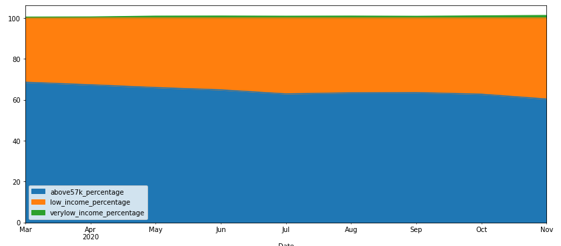

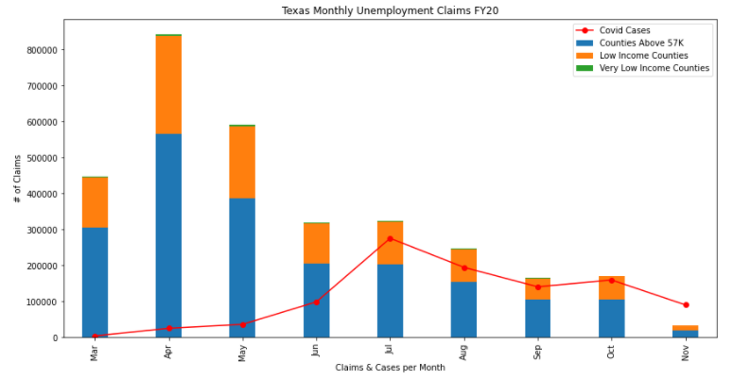

1. What was the effect of Covid-19 on low-income communities vs. the rest of the targeted population?

This analysis was done on a per captia basis to show relevance to a standard scale of measurement across all counties in the state of Texas. This data yielded a lot of information regarding this question, that with more time could have branched off into many subsections. What we found was that even though the smaller counties in the rural areas which made up the majority of what was considered low-income did not have the large population numbers as the other counties their rate of case on a per captia basis was high than larger counties such as Harris county in Houston, Texas one of the six largest counties in the state of Texas. This directly shows that lower income communities suffered an increased rate of infection per captia than its counterpart. This can be due to a variety of factors such as, financial strength, career choice, and quality of healthcare to name a few. The chart below illustrates these measure using a bar chart.

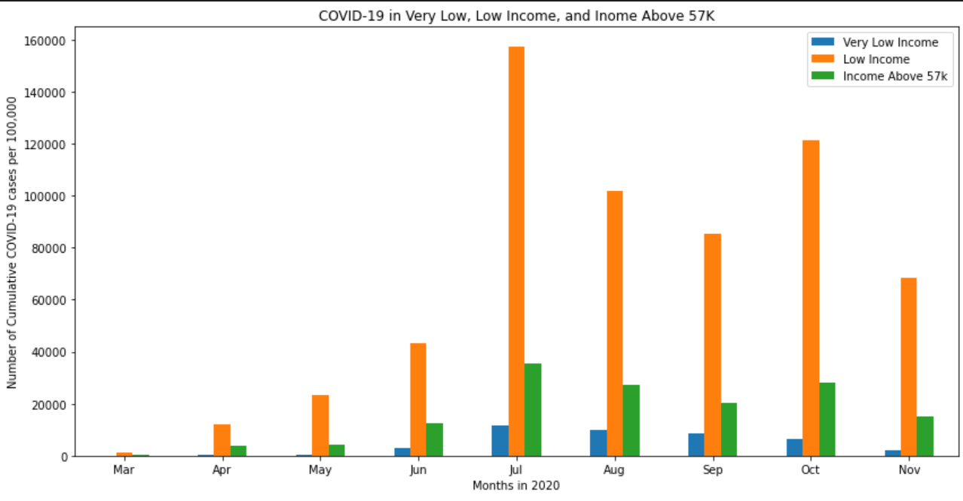

1. How did COVID-19 affect different types of urbanization categories?

The National Center of Health Statistics (NCHS) has developed a means of identify and categorizing counties within a state. The most “central” counties starting off as large metropolitans and the most rural counties consist of nonmetropolitan “noncore”. The focus was to find any correlation using this grouping to see if there was any connection between the type of counties and COVID-19 cases and deaths to their population. The first two charts below show remarkably similar outputs by just the visual look of the bars. As we can see the most heavily populated counties that fell into the category of “Large central metro” and “Medium metro” had more confirmed cases and deaths to date. The data can be pointed to the fact that because of the high population in these counties leads them to more cases and deaths.

